

RELATIONSHIPS, SEX AND HEALTH EDUCATION POLICY

July 2026

Eureka Primary School

Date Minute No. Review date

Approved by Governors 14.07.2026 16/14.07 July 2027

Reviewed by Governors _______________ ________________ ______________

Reviewed by Governors _______________ ________________ ______________

Reviewed by Governors _______________ ________________ ______________
Relationship, Sex and Health and Education Policy (RSE)

An Enriching Learning Journey where we feel safe, happy and comfortable.

Introduction
Relationship, Sex and Health Education is the planned provision for the personal and social development of all pupils.

The acquisition of skills, attitudes, values, knowledge and understanding is essential to ensure that pupils are prepared for the opportunities, rights, responsibilities and experiences of secondary education and future adult life.

We believe that successful RSHE is achieved through formal and informal learning and from experiences and relationships throughout the school and across a rich and varied curriculum.

As a school we value difference and diversity and foster mutual respect, modelling and inspiring attributes in pupils such as respect, courtesy and honesty. These underpin and inform the relationships we have, between pupils and between adults and pupils.

This policy document identifies strategies developed by the staff and takes into consideration both pupil voice and parent / carer view.

This policy is in line with the duties on schools set out in legislation. The Relationships Education, Relationships and Sex Education and Health Education (England) Regulations 2019, made under sections 34 and 35 of the Children and Social Work Act 2017, make relationships education compulsory for all pupils receiving primary education and relationships and sex education (RSE) compulsory for all pupils receiving secondary education. They also make health education compulsory in all schools except independent schools. Parents / carers have the right to request that their child be withdrawn from some or all of sex education delivered as part of statutory RSE.
This is statutory guidance from the Department for Education issued under Section 80A of the Education Act 2002 and section 403 of the Education Act 1996.

For the purposes of this policy we will refer to Relationships Education and Sex Education as combined subjects (RSE), as any learning about the physical and sexual aspects of growing up is taught in the context of positive healthy relationships.

Relationships and Sex Education make a significant contribution to the school’s legal duties to:
• prepare pupils for the opportunities, responsibilities and experiences of adult life, and
• promote the spiritual, moral, social cultural mental and physical development of pupils

Relationships and Sex Education is defined by the PSHE Association as:
’learning about the emotional, social and physical aspects of growing up, relationships, sex, human sexuality and sexual health’.

Ethos of our School
Our education and environment is inclusive where learning is an enriching experience and we reach our full potential through a purposeful, exciting curriculum that is creative, inspiring and challenging. We all have a desire to achieve and be independent learners, with high expectations of ourselves and our behaviour at all times. There is high quality teaching from committed staff with a child-focussed approach to learning. We ensure safeguarding is a golden thread through everything we do. Mutual respect and honesty is developed through trusting relationships where we all feel valued.

Eureka Primary School’s curriculum follows the 7 guiding principles for relationships, sex and health education from the statutory guidance ‘Relationships Education, Relationships and Sex Education (RSE) and Health Education’ September 2026:
- Engagement with pupils.
An inclusive and well-sequenced RSHE curriculum should be informed by meaningful engagement with pupils to ensure that the curriculum is relevant and engaging.
- Engagement and transparency with parents.
Schools should engage with parents on the content of RSHE and be transparent with parents about all materials used in RSHE. All materials should be available to parents. Parents have a right to request that their children are withdrawn from sex education (pupils can opt back in from three terms before they turn 16) and schools should ensure parents are aware of sex education content within lessons in advance.
- Positivity.
Schools should focus on building positive attitudes and skills, promoting healthy norms about relationships, including sexual relationships where relevant, and about health, including mental health. Schools should avoid language which might normalise harmful behaviour among young people – for example gendered language which might normalise male violence or stigmatise boys.
- Careful sequencing.
Schools should cover all statutory topics, recognising that young people can start developing healthy behaviour and relationship skills as soon as they start school. Schools should sequence teaching so that pupils are supported and equipped with the knowledge to navigate different experiences in a positive way before they occur, and to prevent harms.
- Relevant and responsive.
Schools should develop the curriculum to be relevant, age and stage appropriate and accessible to pupils in their area, where appropriate working with local partners and other bodies to understand specific local issues and ensure needs are met.
- Skilled delivery of participative education.
The curriculum should be delivered by school staff or, where schools choose to use them, external providers who have the knowledge, skills and confidence to create a safe and supportive environment and to facilitate participative and interactive education which aims to support and not to alarm pupils. Staff should be trained in safeguarding and offering support, recognising the increased possibility of disclosures.
- Whole school approach.
The curriculum is best delivered as part of a whole school approach to wellbeing and positive relationships, supported by other school policies, including behaviour and safeguarding policies.

Curriculum

Statutory Relationships Education (for all pupils) to be covered by the end of Primary School, and taught by the teachers at Eureka Primary School, are:
- Families and people who care for me
- Caring friendships
- Respectful, kind relationships
- Online safety and awareness
- Being safe

Statutory Health education (for all pupils) encompasses the following:
  - General wellbeing
  - Wellbeing online
  - Physical health and fitness
  - Healthy eating
  - Drugs, alcohol, tobacco and vaping
  - Health protection and prevention
  - Personal safety
  - Basic first aid
  - Developing bodies

Sex Education is not compulsory in primary schools, but we teach sex education in Years 5 and 6, as recommended by the DfE. This is in line with content about conception and birth, which forms part of the national curriculum for science. The national curriculum for science includes subject content in related areas, such as the main external body parts, the human body as it grows from birth to old age (including puberty) and reproduction in some plants and animals. We also cover human reproduction in the science curriculum, but where we do so, this is in line with the factual description of conception in the science curriculum.

Some elements of the RSE curriculum are statutory. Learning about ‘the changing adolescent body’ is part of statutory Health Education. Children will learn key facts about puberty, including physical and emotional changes, about menstruation and the key facts about the life cycle.

National Curriculum Science is also statutory. Pupils are taught to:

Key Stage 1
- identify, name, draw and label the basic parts of the human body and say which part of the body is associated with each sense
- notice that animals, including humans, have offspring which grow into adults

Key Stage 2
- describe the differences in the life cycles of a mammal, an amphibian, an insect and a bird
- describe the life process of reproduction in some plants and animals
- describe the changes as humans develop to old age
- recognise the impact of diet, exercise, drugs and lifestyle on the way their bodies function
- recognise that living things produce offspring of the same kind, but normally offspring vary and are not identical to their parents

Eureka Primary School uses PSHE Matters to teach and deliver our PSHE and RSHE curriculum, as well as NSPCC PANTS. The curriculum for RSHE is included in this policy in Appendix 1 and our PSHE curriculum is Appendix 2.

Our whole-school approach to RSHE enables all of our children to live healthy, safe, productive, capable, responsible and balanced lives, whilst developing the qualities and attributes they need to thrive as individuals, family members and responsible members of a diverse and ever-changing society. Our curriculum content is delivered in an age appropriate way, with regard to the age and stage of pupils.

Every half term, there is an assembly that focusses on ‘safe, happy, comfortable’ and key PSHE and RSHE information to ensure that it is a thread throughout our curriculum and teaching to enable children to understand themselves, their bodies, their privacy and how to keep themselves, and others, safe.

Equality

At Eureka Primary School, we deliver PSHE and RSHE with regards to the Equality Act 2010 and observance of the protected characteristics of age, sex, race, disability, religion or belief, gender reassignment, pregnancy or maternity, marriage or civil partnership and sexual orientation. We recognise that children have varying needs depending on their circumstances and background. We believe that all pupils should have access to PSHE and RSHE that is relevant to their particular needs. To achieve this, the school’s approach will take account of:

- We will consider the particular needs of boy and girls and be proactive in combating sexism, misogyny, sexualised behaviour and sexist bullying. We will foster healthy and respectful peer-to-peer communication and behaviour between all.
- Some children may have learning, emotional and / or behavioural difficulties, or special educational needs or disabilities (SEND) that result in particular needs at times, which we will support. It may also mean that that the PSHE / RSHE curriculum needs adapting to ensure it is accessible to all children through high quality teaching that is adapted and personalised. We will also be mindful of preparing for adulthood outcomes as set out in the SEND Code of Practice when teaching these subjects to those with SEND.
- Different ethnic, cultural and religious groups may have different attitudes and beliefs with regard to PSHE and RSHE. The school will consult children and parents / carers about their needs, take account of their views and promote respect for and understanding of the views of different ethnic, cultural and religious groups in line with safeguarding and school’s statutory duty to keep pupils safe and deliver certain elements of the statutory RSHE curriculum.
- Some of our children may / will go on to define themselves as lesbian, gay, bisexual, transgender, queer or questioning (LGBTQ+) and some children may have parents / carers, brothers or sisters, other family members and/or friends who are LGBTQ+. All our children will meet and work with LGBTQ+ people both now and in the future. Our approach to RSHE will reflect this and teaching will be sensitive and age appropriate both in content and approach. This content will be integrated into the programme rather than as a stand-alone lesson or unit. We actively tackle homophobic bullying.
- We recognise that our children may come from a variety of family situations and home backgrounds. We will take care to ensure that there is no stigmatisation of children based on their home circumstances and deliver the curriculum sensitively and inclusively.

Relationships, Sex Education (RSE)

The Relationships Education, Relationships and Sex Education and Health Education (England) Regulations 2019, made under sections 34 and 35 of the Children and Social Work Act 2017, make Relationships Education compulsory for all children receiving primary education.

This policy sets out both the rights of parents / carers to withdraw children from sex education - but not Relationships or Health Education - and the process that the Headteacher should follow in considering a request from a parent / carer.

We are delivering our relationships and sex education as part of our timetabled RSE, which is taught during the summer term of each school year.

In RSE lessons, we will cover the following areas:
- Learning about different kinds of families (Relationships)
- Learning that some families may have two male or two female parents (Relationships)
- Learning that homophobic bullying or discrimination is wrong and must be reported if it occurs (Relationships)
- Learning that at puberty, adolescents’ emotional feelings for others can change and we can feel attracted to others in a physical way (Relationships)
- Learning that for some people that attraction is to others of the same sex (Relationships)
- Learning what menstruation is and its physical and emotional effects (Health)

As a Primary school, we are not required to teach Sex Education; but must teach Relationships Education and have regard to the statutory guidance in full. At Eureka Primary School, we do teach sex education in Years 5 and 6.

Parents / carers have the right to request that their child be withdrawn from some or all of sex education delivered as part of statutory RSE. The request is to be in writing to the Headteacher.

The PSHE Association Education Programme of Study (Key Stages 1 – 2) is the only national programme of study for the subject and is regularly signposted to by the Department for Education for schools to use. At Eureka Primary School, we use Derbyshire’s ‘PSHE Matters’, which follows the programme of study.

There are twelve modules in ‘PSHE Matters’, constructed around four stages: Early Years (Reception), Key Stage 1 (Years 1 and 2, Lower Key Stage 2 (Years 3 and 4) and Upper Key Stage 2 (Years 5 and 6):
- Drug Education – including how to manage risk and peer influences
- Exploring Emotions – including how to recognise and manage feelings and emotions
- Being Healthy – including the importance of looking after our mental health
- Growing Up – including age-appropriate sex education
- Changes – including loss
- Bullying Matters – including how to ask for help
- Being Me – including identity and community
- Difference and Diversity – including challenging stereotypes
- Being Responsible – including looking after the environment
- Being Safe – including online and offline
- Relationships – including what is a healthy relationship
- Money Matters – including enterprise

Emotional Health and Well-being
The statutory guidance for health education covers physical health, mental health and emotional well-being. It recognises that physical health and mental health are interlinked, that good physical health contributes to good mental health, and vice versa.

Irrespective of statutory requirements, teaching about mental health and emotional well-being as part of a comprehensive RSE education curriculum is vital. It promotes children’s well-being through an understanding of their own and others’ emotions and the development of healthy coping strategies. It also contributes to safeguarding, providing children with knowledge, understanding and strategies to keep themselves healthy and safe, as well as equipping them to support others who are facing challenges. Finally, talking openly about mental health concerns is an effective means of breaking down any associated stigma.

The emphasis should always be on developing children’s knowledge, understanding, skills, language and confidence to seek support, as needed, for themselves or others. They should understand when to seek help, what help is available, and the likely outcome of seeking support.

As with any aspect of RSE, learning about mental health must build up from early learning if it is to be most effective. With very young children, for example, rehearsing ways of asking an adult for help, and persevering if their requests are not listened to, lays the foundations for confidently accessing sources of support when they are older.

A Safe Learning Environment

Our RSHE is taught in a safe, non-judgmental environment where adults and children are confident that they will be respected. Teachers and children develop and establish ground rules together, which ensure that every child feels safe and is able to learn in a supportive and caring environment. These cover, in particular, the asking and answering of personal questions and strategies for checking or accessing information. In order for RSHE to be conducted safely, the following will be in place:
- Group agreements / ground rules are negotiated, explained, displayed and referred to every lesson.
- No one in the classroom will be expected to answer a personal question.
- Distancing techniques, such as the use of scenarios, will be used to help to keep children safe.
- There will be no need for anyone to discuss their own personal issues.
- Confidentiality will be clearly explained. Children will understand how disclosures will be handled.
- Children will be expected to engage and listen during lessons, however, it is accepted that sometimes it is inappropriate for them to be expected to take part in the discussion.
- The correct names for body parts will be used and taught to be used (with an understanding of other names / word used).
- The meanings of words will be explained in a sensible and factual way.
- Care will be taken not to use materials or approaches that may trigger trauma or distress.
- Children at risk will be identified and arrangements made for them to access the learning in a comfortable way.
- Signposting to sources of support when dealing with sensitive issues.
- A box for anonymous written questions will be provided and questions answered (unless inappropriate or not appropriate for the age of children).

Asking and Answering Questions

Teachers will answer children’s questions and concerns in a sensitive, age and development appropriate manner. If unsure, then teachers will refer to the PSHE and RSHE Lead for advice and support.

Teachers will apply the following principles:
- Clear guidance will be established about what is appropriate and inappropriate in a whole class setting-group agreement / ground rules will help to achieve this.
- If a child’s question is inappropriate to address the whole class, the teacher will acknowledge the question and attend to it later on an individual basis.
- Personal questions should be referred to the ground rules / group agreement.
- Teachers will set the tone by speaking in a matter-of-fact way and ensuring that children discuss issues in a way which encourages thoughtful participation.
- If a teacher is concerned that a child is at risk in any way, including sexual abuse or exploitation, the usual safeguarding procedures will be followed.
- If a child asks a question that is not part of the school’s sex education coverage or the child has been withdrawn from the sex education and asks then they will be informed that it is not part of our curriculum and they can talk to a grown up at home about it.

We acknowledge that sensitive and potentially difficult issues will arise in our RSHE curriculum, as children will naturally share information and ask questions. When spontaneous discussion arises, it is guided in a way that reflects the stated school aims and curriculum content.

It is important that pupils feel able to ask any questions that they wish and that their questions are valued. However, consideration will be given in regards to the pupil’s age, prior learning or readiness. Pupils also have access to a questions box in each class in order for them to write questions down and be answered as they request. These questions may be answered in a 1: 1 situation if it is appropriate or as part of a class discussion. If a safeguarding issue is raised, we will take the appropriate actions (see Safeguarding Policy) and ensure that this concern is dealt with promptly.

Resources

We primarily use the ‘PSHE Matters’ scheme and also NSPCC PANTS as well as teaching and learning resources shared by Derbyshire County Council through training. Resources are also purchased, such as books, or accessed online, such as videos. All resources are read and watched before use to ensure they are suitable, age appropriate and support the teaching and learning.

Parents / carers can access any resources used in our RSHE curriculum and lessons to read and watch. Parents / carers are informed of this in a letter that is sent prior to the teaching of RSHE across school.

Confidentiality

Children may disclose personal information that staff will respond to appropriately. Where there is a genuine risk to the safety of the child, information will be passed on to individuals and/or organisations responsible for protecting the child. We will follow the procedures outlined in other policies such as Safeguarding and Child Protection, Behaviour and Health and Safety.
Any information disclosed to a staff member or other responsible adult, which causes concern about the child’s safety, will be communicated to the Designated Safeguarding Lead as soon as possible.

Assessment, Recording and Reporting

We assess children’s learning in line with approaches used in the rest of the curriculum. Children’s learning is planned using learning outcomes, which are explained to the children. Key questions as well as learning knowledge are expected. Teacher assessment is used to provide an overview of the child’s learning within a unit of work, and to assess whether the child is working at the expected level, working towards or working beyond it. We report to parents / carers at the end of the school year through an annual report and also have parents’ evenings twice a year.

Parental Engagement in RSHE

We recognise the prime role of parents / carers in the development of their child’s understanding about relationships and sex. We work in active partnership with parents / carers in the development and review of RSE. The school will ensure that parents / carers are: made aware of the school’s approach and rationale for RSE through the policy; are involved in the review of the RSHE policy; made aware of the school’s PSHE curriculum; and encouraged to support their child’s learning at home through shared learning activities, if appropriate. Resources are available for parents / carers to borrow to reinforce learning at home and support them in managing conversations with their children on these issues.

Parents / carers have a legal right to withdraw their children from dedicated sex education lessons delivered outside the science curriculum. They do not have a right to withdraw their children from those aspects of RSE that are taught in national curriculum Science, Relationships Education or Health Education. If a parent / carer has any concerns about the RSE provision, we will take time to address their concerns and allay any fears they may have. If parents / carers decide to withdraw their child, we shall work with them and their child to explore possible alternative provision. In the event of a written request to withdraw, we will document this process and ensure a record is kept.

Working with Staff

Within the context of the School Improvement Plan, support and training will be made available to all staff as appropriate. This includes allocating time at staff meetings or INSET to introduce new areas of work; review the effectiveness of the approaches used and where there is development in the curriculum, teaching and learning.
The PSHE and RSHE Lead is entitled to receive training in their role and responsibilities. This supports the development of the school’s policy, practice and provision. This includes the curriculum and approaches to teaching and learning, as well as whole school approaches to promoting health and well-being. The Lead also takes responsibility for supporting other members of staff in their work relating to PSHE and RSHE, which may include ensuring appropriate training opportunities.
The role of Governors

When aspects of PSHE and RSHE are in the school improvement plan, the governors will be asked to reflect on, monitor and review the work as appropriate. The Link Governor will play an active role in monitoring, reviewing and developing the policy and its implementation in school, reporting back as necessary to the whole governing body.

Monitoring and Evaluation

- The PSHE and RSHE Lead will regularly evaluate the curriculum, content, teaching and learning. The views of children, staff who deliver the curriculum, parents / carers and governors are used to make changes and improvements to the programme on an on-going basis.
- This policy will be reviewed by the PSHE and RSHE Lead / Headteacher and the governing body.

This policy is in line with DfE ‘Relationships Education, Relationships and Sex Education (RSE) and Health Education: Statutory guidance for governing bodies, proprietors, head teachers, principals, senior leadership teams, teachers’ July 2025, and should be read in conjunction with:

- Keeping Children Safe in Education (statutory guidance)
- Respectful School Communities: Self Review and Signposting Tool (a tool to support a whole school approach that promotes respect and discipline)
- Behaviour and Discipline in Schools (advice for schools, including advice for appropriate behaviour between pupils)
- Equality Act 2010
- SEND code of practice: 0 to 25 years (statutory guidance)
- Alternative Provision (statutory guidance)
- Mental Health and Behaviour in Schools (advice for schools)
- Preventing and Tackling Bullying (advice for schools, including advice on cyberbullying)
- Sexual violence and sexual harassment between children in schools (advice for schools)
- The Equality and Human Rights Commission Advice and Guidance (provides advice on avoiding discrimination in a variety of educational contexts)
- Promoting Fundamental British Values as part of SMSC in schools (guidance for maintained schools on promoting basic important British values as part of pupils’ spiritual, moral, social and cultural (SMSC)

This policy document is freely available on request to the entire school community.
Our policy has been produced by the PSHE / RSHE Lead in conjunction with teachers and parents / carers, with the governing body agreeing and ratifying the policy. Through staff meeting time, teachers received training and CPD, and shaped and advised the policy. Parents / carers were consulted via a Microsoft Form, which shaped and advised the policy and have been informed of updates and changes and their views sought.
PSHE & RSE Lead: Cassie Hurt
Date of Policy: July 2026
Next review date: March 2027

Appendix 1

EUREKA PRIMARY SCHOOL: RELATIONSHIPS, SEX AND HEALTH EDUCATION
PSHE MATTERS: GROWING UP Unit
This is taught in Summer 2 half term.
Curriculum coverage / content in PURPLE is sex education in Years 5 and 6.
NSPCC: PANTS | 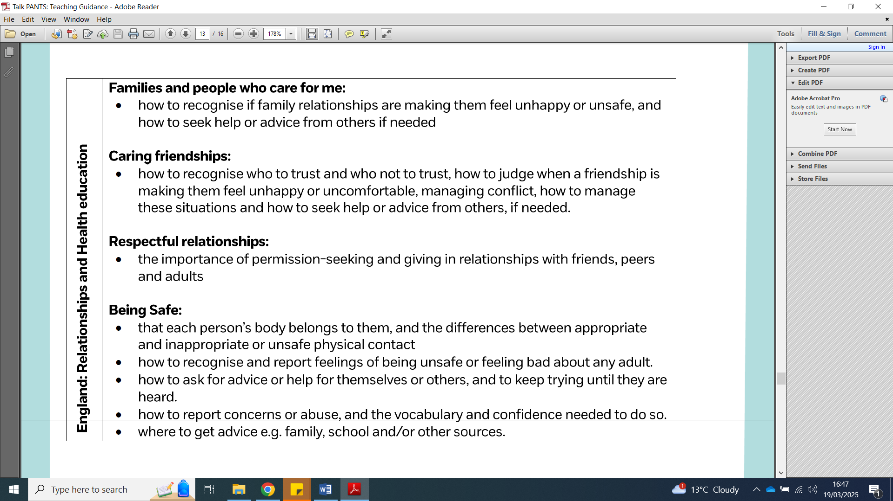 | Talk PANTS encourages simple conversations with children to help keep them safe, teaching children five key messages:  - Privates are private (correct vocabulary for body parts will be used consistently).  - Always remember your body belongs to you - knowing the difference between appropriate and inappropriate touch.  - No means no - understanding that they have the right to say “no” to unwanted touch.  - Talk about secrets that upset you.  - Speak up, someone can help.
EYFS
EYFS | NSPCC: PANTS EYFS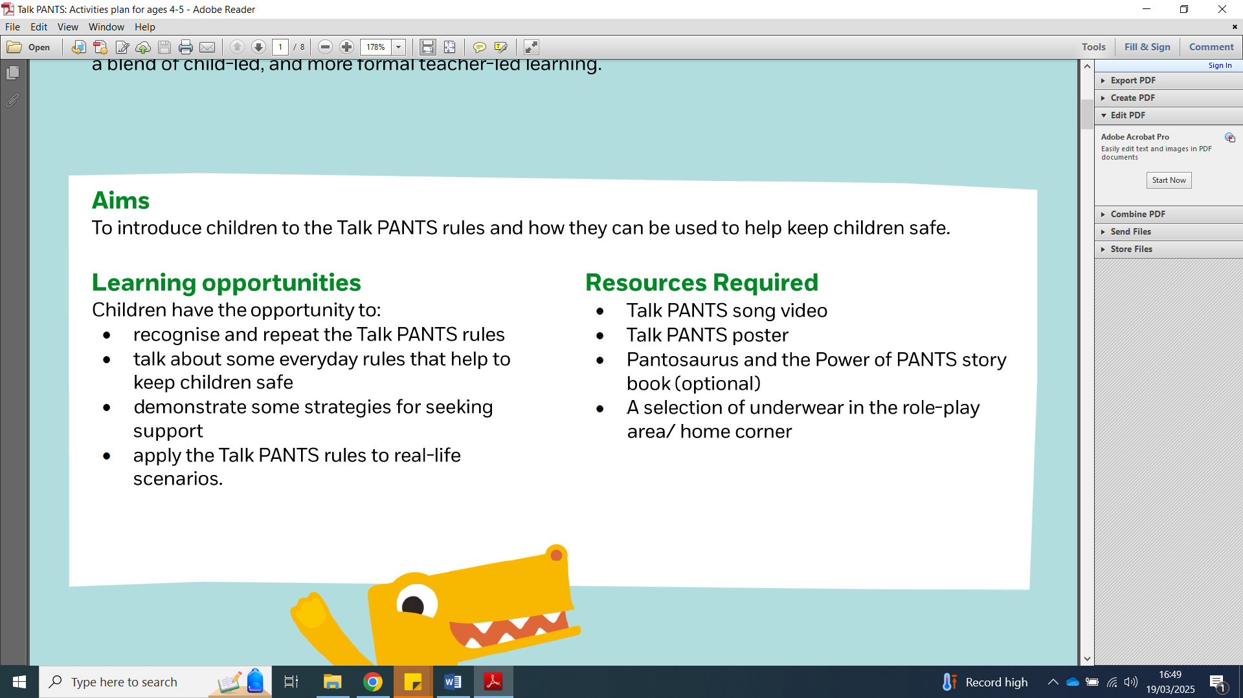 | PSHE MATTERS: EYFS Growing and Changing  - Become aware that people grow and change from babies into children and adults.  - Notice and talk about changes in themselves and others.  PSHE MATTERS: EYFS Privacy, Boundaries and Consent  - Begin to understand that their body belongs to them and that some parts of the body are private.  - Know that there are trusted adults who help keep them safe.  - Become aware that some touch is safe and caring (e.g. help from a parent or carer), and some touch is not okay.  - Learn that if something makes them feel worried, confused or upset, they should tell a trusted adult.
KS1
YEAR 1 | NSPCC: PANTS POWER 5 - 7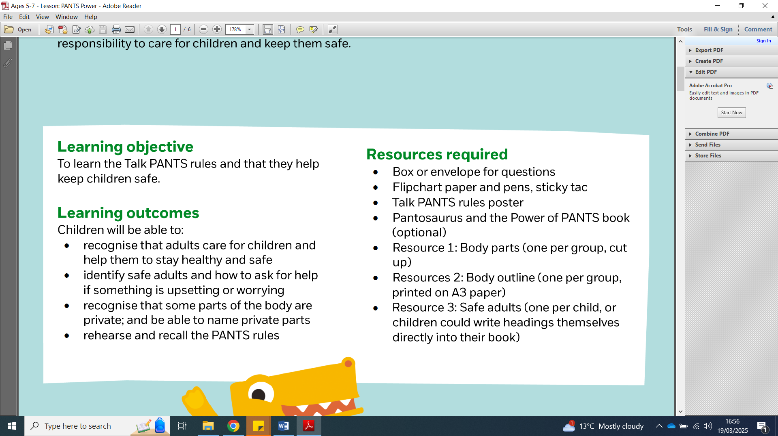 | PSHE MATTERS: KS1 Growing and Changing  - Name the main parts of the body including vulva, vagina and penis.  - Recognising the difference between male and female body parts.  - Understand the human life cycle and that people grow from young to old.  - Talk about some ways to keep clean.  - Recognise what makes them special and unique.  PSHE MATTERS: KS1 Privacy, Boundaries and Consent  - Understand that some parts of the body are private.
YEAR 2 | NSPCC: MORE PANTS POWER 5 – 7  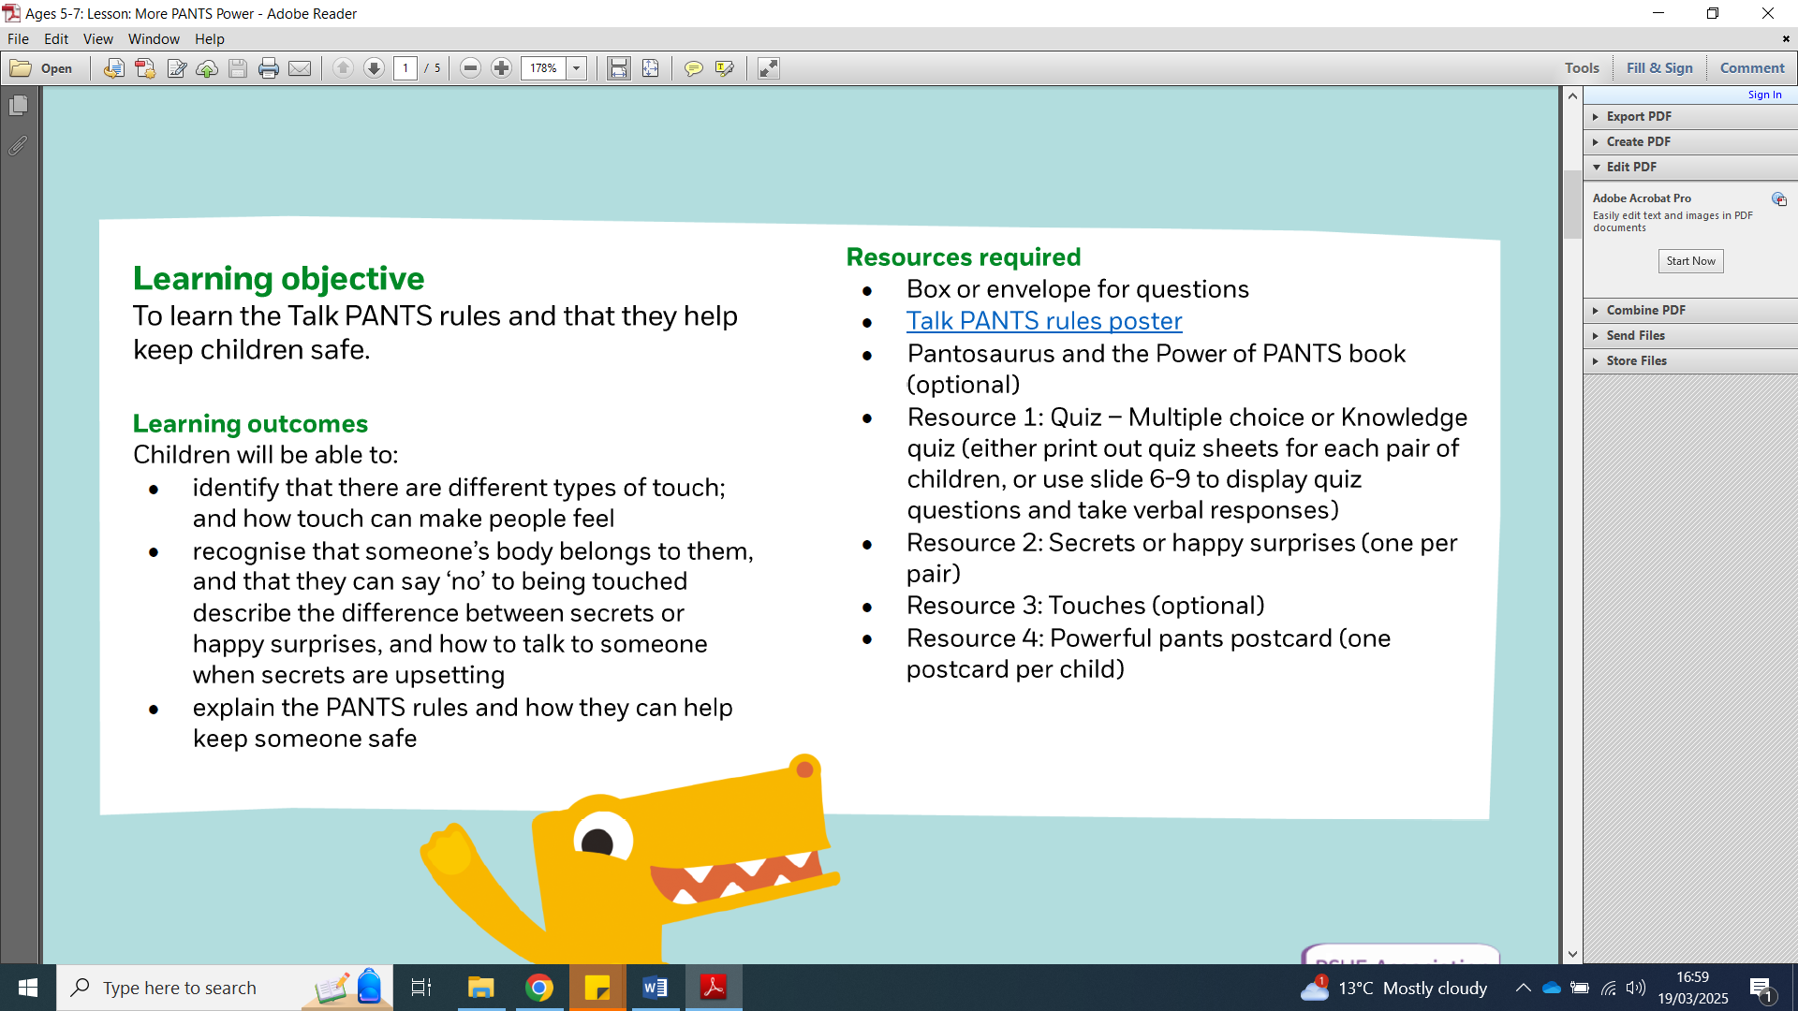 | PSHE MATTERS: KS1 Growing and Changing  - Name the main parts of the body including vulva, vagina and penis.  - Recognising the difference between male and female body parts.  - Describe ways that people’s needs and bodies change as they grow.  - Understand that babies grow in the mothers’ body and have particular needs when they are born.  PSHE MATTERS: KS1 Privacy, Boundaries and Consent  - Understand that some parts of the body are private.  - Identify different types of touch and how they make people feel.  - Understand the difference between happy surprises and secrets that make them feel uncomfortable or worried and how to get help.
LKS2
YEAR 3 | NSPCC: PANTS BUIDLING CONFIDENCE 7 - 9  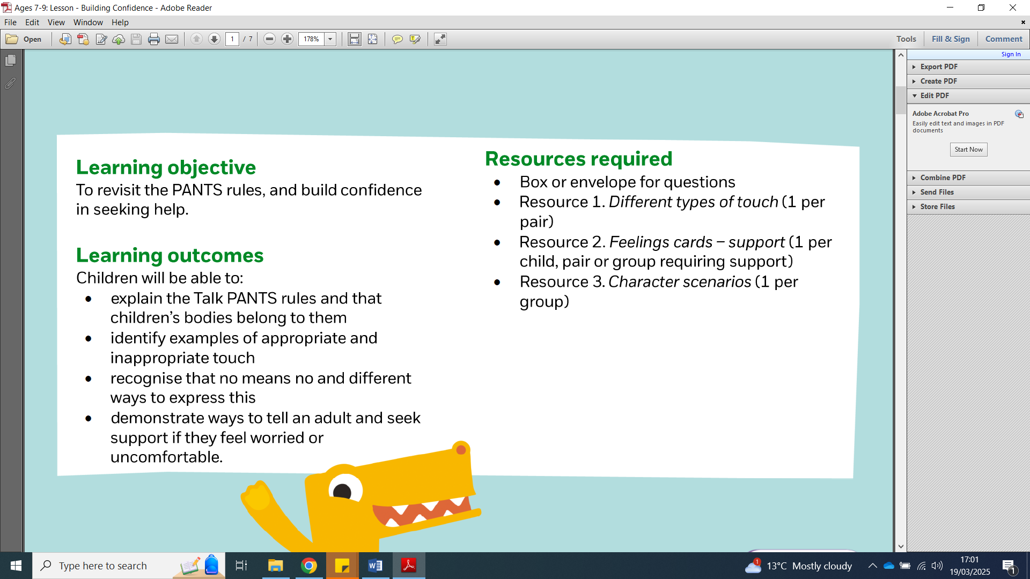 | PSHE MATTERS: LKS2 Growing and Changing  - Name external genitalia and some reproductive organs including penis, vulva, vagina, testicles, scrotum, nipples, womb.  - Understand the processes of reproduction and birth as part of the human life cycle.  - Explain how daily hygiene helps to reduce the spread of infection.  - Recognise that individuality and personal qualities contribute to who we are.  PSHE MATTERS: LSK2 Privacy, Boundaries and Consent  - Explain what is meant by privacy and personal boundaries.  - Know when it is right to break or keep a confidence or share a secret. Know how to ask for help.
YEAR 4 | NSPCC: PANTS BUIDLING CONFIDENCE 7 - 9 | PSHE MATTERS: LKS2 Growing and Changing  - Name external genitalia and some reproductive organs including penis, vulva, vagina, testicles, scrotum, nipples, womb.  - Understand the processes of reproduction and birth as part of the human life cycle.  - Begin to explore physical and emotional changes that happen during puberty.  - Explain how daily hygiene helps to reduce the spread of infection.  - Explain how adults care for a baby during and after pregnancy.  PSHE MATTERS: LSK2 Privacy, Boundaries and Consent  - Explain what is meant by privacy and personal boundaries.  - Recognise uncomfortable / comfortable behaviour online / offline.  - Know when it is right to break or keep a confidence or share a secret. Know how to ask for help.
UKS2
YEAR 5 | NSPCC: PANTS HOW CAN THE PANTS RULES HELP US? 9 – 11  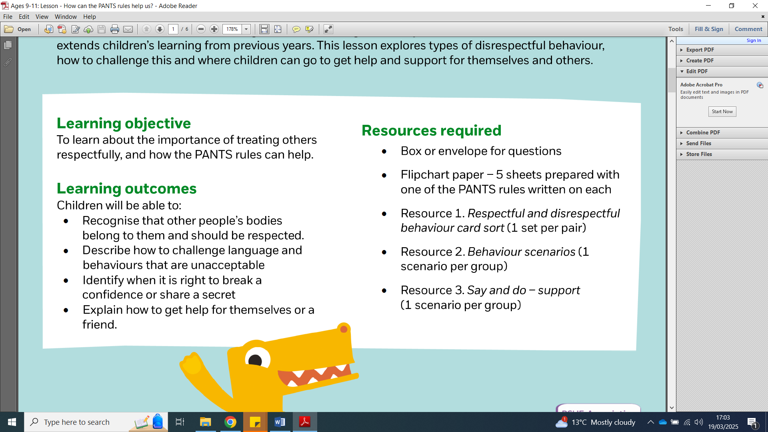 | PSHE MATTERS: UKS2 Growing and Changing  - Identify the external genitalia and internal reproductive organs and how the process of puberty relates to human reproduction.  - Identify the physical and emotional changes that happen when approaching / during puberty.  - Know some key facts about menstruation.  - Identify the importance of keeping clean and how to maintain personal hygiene whilst growing and changing.  - Identify and value personal strengths, skills, achievements and interests.  PSHE MATTERS: USK2 Privacy, Boundaries and Consent  - Understand what consent means and how to seek and give/not give permission in different situations.  - Analyse when behaviour including physical touch is acceptable, unacceptable, wanted or unwanted in different situations.  - Respond appropriately if someone asks you to keep a secret that makes you feel uncomfortable. Identify who to ask for help.
YEAR 6 | NSPCC: PANTS HOW CAN THE PANTS RULES HELP US? 9 – 11 | PSHE MATTERS: UKS2 Growing and Changing  - Identify the external genitalia and internal reproductive organs and how the process of puberty relates to human reproduction.  - Explain how babies are conceived (including that contraception can be used to stop a baby from being conceived), born and cared for  - Identify the physical and emotional changes that happen when approaching / during puberty.  - Know some key facts about menstruation.  - Reflect on the responsibilities of being a parent or carer and how having a baby changes someone’s life.  PSHE MATTERS: USK2 Privacy, Boundaries and Consent  - Understand what consent means and how to seek and give / not give permission in different situations.  - Analyse when behaviour including physical touch is acceptable, unacceptable, wanted or unwanted in different situations.  - Respond appropriately if someone asks you to keep a secret that makes you feel uncomfortable. Identify who to ask for help.

Appendix 2

 Eureka Primary School Long Term Plan: PSHE / RSHE

An enriching learning where we ALL feel Safe, Happy, Comfortable.

PSHE MATTERS 2026 – 2027
 | Autumn 1 | Autumn 2 | Spring 1 | Spring 2 | Summer 1 | Summer 2
EYFS  ADVENTURERS | Being Me | Bullying Matters | Being Safe | Drug Education | Exploring Emotions | Relationships  Growing Up
Years 1 & 2  THINKERS | Being Me | Bullying Matters | Being Safe | Drug Education | Exploring Emotions | Relationships  Growing Up
Years 2 & 3  EXPLORERS | Being Me | Bullying Matters | Being Safe | Drug Education | Exploring Emotions | Relationships  Growing Up
Years 4 & 5  INVESTIGATORS | Being Me | Bullying Matters | Being Safe | Drug Education | Exploring Emotions | Relationships  Growing Up
Years 5 & 6  ENQUIRERS | Being Me | Bullying Matters | Being Safe | Drug Education | Exploring Emotions | Relationships  Growing Up

PSHE MATTERS 2027 – 2028
 | Autumn 1 | Autumn 2 | Spring 1 | Spring 2 | Summer 1 | Summer 2
EYFS  ADVENTURERS | Being Healthy | Differences and Diversity | Being Responsible | Money Matters | Changes | Relationships  Growing Up
Years 1 & 2  THINKERS | Being Healthy | Differences and Diversity | Being Responsible | Money Matters | Changes | Relationships  Growing Up
Years 2 & 3  EXPLORERS | Being Healthy | Differences and Diversity | Being Responsible | Money Matters | Changes | Relationships  Growing Up
Years 4 & 5  INVESTIGATORS | Being Healthy | Differences and Diversity | Being Responsible | Money Matters | Changes | Relationships  Growing Up
Years 5 & 6  ENQUIRERS | Being Healthy | Differences and Diversity | Being Responsible | Money Matters | Changes | Relationships  Growing Up

PSHE MATTERS CURRICULUM
ADVENTURERS: EYFS | THINKERS: Years 1 & 2 | EXPLORERS: Year 2 & 3 | INVESTIGATORS: Years 4 & 5 | ENQUIRERS: Years 5 & 6
EYFS | KS1 | KS1 / LKS2 | LKS2 / UKS2 | UKS2

