


ATTENDANCE POLICY

May 2026

Eureka Primary School

Date Minute No. Review date

Approved by Governors 25/03/2025 16/25.03 December 2025

Reviewed by Governors 29/09/2025 23/29.10 Sept 2026

Reviewed by Governors 19/05/2026 16/14.07 May 2027

EUREKA PRIMARY SCHOOL ATTENDANCE POLICY

This policy has been written to adhere to the relevant Children Acts, Education Acts, Regulations and Guidance from the Department for Education in addition to guidance from the Local Authority.

Parents / carers have the legal responsibility for ensuring their child regularly attends school.

Attendance is important at Eureka Primary School, and we also promote and support punctuality. We believe that every child has the right to the best education and, if they are not in school, they are not learning.

EVERY DAY REALLY DOES COUNT.

Attendance below 95% can adversely affect the academic progress of a child and limit their social development as they have reduced access to activities that promote this: excellent attendance = better pupil outcomes. Evidence shows that those pupils with attendance above 95% make better progress than those whose attendance is below 95%.

AIMS

This attendance policy ensures that all staff, governors and parents / carers in our school are fully aware of and clear about the actions necessary to promote good attendance.

We expect all children on roll to attend every day, when the school is in session, as long as they are fit and healthy enough to do so. We do all we can to encourage the children to attend and to put in place appropriate procedures. We believe that the most important factor in promoting good attendance is development of positive attitudes towards school. To this end, we strive to make our school a happy and rewarding experience for all children. We will also make the best provision we can for those children who, due to ill health, are prevented from coming to school.

It is the expectation of everyone within the wider school community to support pupils to:
- Attend school regularly
- Attend school punctually
- Attend school prepared

We will achieve this by:
- Promoting good attendance
- Reducing absence, including persistent and severe absence
- Ensuring every child has access to the full-time education to which they are entitled
- Acting early to address patterns of absence
- Building strong relationships with families to ensure children have the support in place to attend
School

LEGISLATION AND GUIDANCE

This policy meets the requirements of the working together to improve school attendance from the Department for Education (DfE), following legislation setting out the legal powers and duties that govern school attendance:
- Part 6 of The Education Act 1996
- Part 3 of The Education Act 2002
- Part 7 of The Education and Inspections Act 2006
- The Education (Pupil Registration) (England) Regulations 2006 (and 2010, 2011, 2013, 2016 amendments)
- The Education (Penalty Notices) (England) (Amendment) Regulations 2013

This policy also refers to the DfE’s guidance on the school census, which explains the persistent absence threshold.

DEFINITIONS

Authorised absence
An absence is classified as authorised when a child has been away from school for a legitimate unavoidable reason and the school has received notification from a parent or carer. For example, if a child has been unwell and the parent / carer telephones the school to explain the absence.

Unauthorised absence
An absence is classified as unauthorised when a child is away from school without the permission of the school, even if the absence is supported by the parent / carer.

Only the Headteacher can decide on whether an absence is authorised or not. Sometimes, even if absence is supported by parent / carer, an absence will be unauthorised.

ROLES AND RESPONSIBILITIES

Governing Body is responsible for:

- promoting the importance of school attendance across the school’s policies and ethos;
- making sure school leaders fulfil expectations and statutory duties;
- regularly reviewing and challenging attendance data;
- monitoring attendance figures for the whole school;
- making sure staff receive adequate training on attendance and
- holding the Headteacher to account for the implementation of this policy.

Headteacher is responsible for:

- the implementation of this policy;
- monitoring school-level absence data and reporting it to governors;
- monitoring and analysing attendance data;
- benchmarking attendance data to identify areas of focus for improvement;
- monitoring the impact of any implemented attendance strategies;
- leading attendance across the school;
- offering a clear vision for attendance improvement;
- evaluating and monitoring expectations and processes;
- having an oversight of data analysis;
- devising specific strategies to address areas of poor attendance identified through data;
- sending attendance letters and arranging calls and meetings with parents / carers to discuss
attendance issues;
- organising the delivery of targeted intervention and support to children and families;
- working with school partners, the Local Authority and Education Welfare Officers to tackle
persistent absence and
- issuing fixed-penalty notices, where necessary.

Teachers are responsible for:
Teachers are responsible for recording attendance on a daily basis, using the correct codes, and submitting this information to the school office via Integris (the school information system). In addition, teachers should report any attendance concerns or non-attendance patterns to the Headteacher. Teachers should also promote good attendance through positive praise and parental communication.

School Office Staff are responsible for:

- answer calls, and listening to answer machine messages, from parents / carers about absence on a
day-to-day basis and recording it on the school system;
- make initial phone calls to parents / carers if a child is absent and the school have not been
informed as to why;
- transfer calls from parents / carers to the Headteacher, in order to provide them with more
detailed support on attendance;
- arranging and sending attendance letters for authorised and unauthorised absence and
- arranging and sending forms to the Local Authority re issuing fixed-penalty notices, where
necessary.

Parents / Carers are responsible for:

- making sure their child attends school every day and on time (school starts at 8.45am and finishes at
3.15pm);
- call the school to report their child’s absence before 8.45am on the day of the absence, and each
subsequent day of absence, and advise on why they are absent and when they are expected to
return;
- provide the school with at least 2 emergency contacts, with phone numbers, for their child;
- ensure their child is collected on time at the end of the school day, at 3.15pm, and
- ensure that, where possible, appointments for their child are made outside of the school day.

All absences should be reported by calling the school office on 01283 216451.

Pupils are expected to:

- attend school every day;
- arrive at school on time and
- have the correct clothing and equipment required for the school day.

RECORDING ATTENDANCE

Attendance Register
The school gates are open at 8.40am and the children are expected to be in school, in their classroom, by 8.45am, when the register is taken. Afternoon register is taken at 1.00pm.
Each class teacher has the responsibility for marking the attendance register at the beginning of the morning and afternoon session. All attendance records are documented using Integris.
There are two sessions per day marked for attendance, 8.45am and 1.00pm. The register will mark each child as:
- present;
- attending an approved off-site educational activity;
- absent, or
- unable to attend due to exceptional circumstances.

Any amendment to the attendance register will include:
- the original entry;
- the amended entry;
- the reason for the amendment;
- the date on which the amendment was made and
- the name and position of the person who made the amendment.

See Appendix 1 for the DfE attendance codes.

We will also record:
- whether the absence is authorised or not;
- the nature of the activity if a child is attending an approved educational activity, or
- the nature of circumstances where a child is unable to attend due to exceptional circumstances.

We will keep every entry on the attendance register for 6 years after the date on which the entry was made.

It is essential that children arriving and leaving school with a parent / carer in the school day are signed in or out from the school office. The signing in / out register in the office is used in the case of an emergency or a fire drill.

Lateness and Punctuality

Children who are persistently late after close of register soon fall behind with their learning.

A child who arrives late:
- before the register has closed (after 8.45am but before 9.00am) will be marked as Late. Records are kept for those children who are late; this is documented on the electronic register for each child, using code L.
- after the register has closed (after 9.00am) will be marked as absent. This is an unauthorised absence for the whole session and will affect the child’s overall attendance percentage and can be used to calculate absence thresholds for legal decision making.
- If a child is persistently late (more than 6 times within a half term) the parent / carer will receive a letter informing them of this. If the situation does not improve (6 more lates), a meeting will be held in school to look at ways to improve punctuality.

Children who have attended a dentist, doctor’s or medical appointment and subsequently come to school later than 9.00am will have the absence recorded as a medical absence, using code M.

Unplanned absence

The child’s parent / carer must notify the school of the reason for absence on the first day of an unplanned absence by 8.45am or as soon as practically possible by calling the school office on 01283 216451. Parents / carers should call the school office and report an absence using Option 1 or 2.

We will mark absence due to illness as authorised unless the school has a genuine concern about the authenticity of the illness. If the authenticity of the illness is in doubt or there are concerns about persistent absence, the school may ask the child’s parent / carer to provide medical evidence, such as a doctor’s note, prescription, appointment card or other appropriate form of evidence. We will not ask for medical evidence unnecessarily. If the school is not satisfied about the authenticity of the illness, the absence will be recorded as unauthorised and parents / carers will be notified of this in advance.

Planned Absence

Attending a medical or dental appointment will be classed as authorised as long as the child’s parent / carer notifies the school in advance of the appointment. However, we encourage parents / carers to make any appointments for their child out of school hours, where possible. Where this is not possible, the child should out of school for the minimum amount of time necessary.

Parents / carers can notify the school office of any planned absence by speaking to the school office or calling 01283 216451.

The child’s parent / carer must also apply for other types of term-time absence as far in advance as possible of the requested absence. Any requests for term time leave should be made on a ‘Leave of Absence Request’ form, available from the school office and handed in at least two school weeks before the first date of the requested absence whenever possible. Written authorisation must be received before the child can be absent from school.

Following up Unexplained Absence

Where any child we expect to attend school does not attend, or stops attending, without reason, the school will:
- On day 1, the school office will call the parent /carer. Subsequent phone calls will be made, leaving a message to contact school if available to do so. If no response, a ParentMail will sent asking the parent / carer to contact school. If school have not been contacted by 10.30am, there will be a visit to the home for a safe and well-being check.
If no one is at home when the safe and well-being check has been made, all other emergency contacts will be called to ascertain the safety and whereabouts of the child.
- On day 2 (if no contact made on day 1), phone call to parent / carer is made and if no answer then all other emergency contacts will be called. If no answer, school staff will visit the home address again. If no contact is made, the police / social care will be called (depending on the individual circumstance of the child) and this would be considered a serious safeguarding risk.
- Identify whether the absence is approved or not.
- Identify the correct attendance code to use and input onto the system as soon as the reason for
absence is ascertained – this will be no later than 5 working days after the session.
- Call the parent / carer on each day that the absence continues without explanation to ensure
proper safeguarding action is taken where necessary.
- If absence continues, the school will arrange for an attendance meeting with the Headteacher.

AUTHORISED AND UNAUTHORISED ABSENCE
Approval of Term-time Absence

Pupils should not be taken out of school during term time unless it is unavoidable. The Headteacher is required to consider requests for leave of absence in term time and will only approve the leave if there are exceptional circumstances. A leave of absence will not be granted for a family holiday. A leave of absence is granted at the Headteacher’s discretion, including the length of time the child is authorised to be absent for.

The school considers each application for term-time absence individually, taking into account the specific facts, circumstances and relevant context behind the request. Any request should be submitted as soon as it is anticipated and, where possible, at least two weeks before the absence, and in accordance with any leave of absence request form, accessible via the school office. The Headteacher may require evidence to support any request for leave of absence.

Valid reasons for authorised absence include:
- Illness and medical / dental appointments.
- Religious observance – where a day is ‘exclusively set apart for religious observance by the religious body to which the pupil’s parents belong” (The Education Act 1996 S444(3) (c)). If necessary, the school will seek advice from the parents’ religious body to confirm whether the day is set apart.
- Traveller pupils travelling for occupational purposes – this covers Roma, English and Welsh gypsies, Irish and Scottish travellers, showmen (fairground people) and circus people, bargees (occupational boat dwellers) and new travellers. Absence may be authorised only when a traveller family is known to be travelling for occupational purposes and has agreed this with the school, but it is not known whether the pupil is attending educational provision.

When considering granting the leave of absence as exceptional circumstance, the Headteacher will consider:
- the amount of time requested;
- circumstances of the request;
- frequency of the request;
- previous leave of absences taken within child’s school career;
- when the request was made;
- the child’s current attendance record, including previous academic years (leave will not be granted where a child’s attendance is below 90%);
- the impact that absence will have on a child’s attendance record;
- the impact on the child’s education and their ability to catch up on the work that would be missed.

Unauthorised absence

In September 2013, the government introduced new regulations making it clear that Headteachers must not give approval for any leave of absence during term time, including holidays, unless there are exceptional circumstances.
Any requests for term time leave should be made on a ‘Leave of Absence’ request form available from the school office and handed in at least two school weeks before the first date of the requested absence whenever possible. You must have received written authorisation received before a child can be absent from school.

Parents / carers may be issued with a penalty notice fine or prosecution should leave of 5 days or more be taken which is not authorised by the Headteacher, or where repeated incidents of leave in term time for less than 5 days occur or where the unauthorised absence contributes to wider poor attendance that meets the legal threshold. Absence deemed for the reason of unauthorised leave in term time will be marked in the register with the Attendance code G.

You may be issued with a Penalty Notice should leave be taken which is not authorised. If unpaid this could lead to prosecution under section 444(1) of The Education Act 1996.

National Framework for Penalty Notices

To provide consistency, the Government have introduced a new national framework for when schools and Local Authorities believe that they have exhausted all offers of support and the parent / carer is not engaging with the attempt to improve their child’s attendance at school.

The threshold for when a school should consider next steps is 10 sessions (5 school days) of unauthorised absence in a rolling period of 10 school weeks. A school week means any week in which there is at least one school session. This can be made up of any form of unauthorised absence, including late after close of register (attendance code U) and odd days of unauthorised absence (attendance code O) which add up to 5 days within a 10-week period.
At this point the school will consider if it is likely that the attendance will improve with further support. They may then decide to refer the case to the Local Authority for formal monitoring. This may proceed to legal action if the attendance does not improve.

Education Penalty Notices are issued to parents / carers of statutory school age children. They can be issued to each parent or carer who is deemed liable for the child’s absence from school. The costs and process is outlined below:

First Offence - The first time a Penalty Notice is issued for Term Time Leave or Irregular Attendance the amount will be £160 per parent / carer, per child, paid within 28 days. This is reduced to £80 per parent / carer, per child if paid within 21 days.

Second Offence (within 3 years) - The second time a Penalty Notice is issued for Term Time Leave or Irregular Attendance the amount will be £160 per parent / carer, per child paid within 28 days.

Third Offence and Any Further Offences (within 3 years) - The third time an offence is committed for Term Time Leave or Irregular Attendance a Penalty Notice will not be issued, and the case will be presented straight to the Magistrates’ Court.

Children not collected at the end of the school day

The following procedure is followed when children are not collected by an appropriate adult at the end of the school day or extracurricular activity / school visit:
- if not collected at 3.15pm (or time of when after school activity / school visit finishes), children are kept safe with a member of school staff and attempts will be made to contact parents / carers, or other adults on the child’s contact list;
- if no contact is made, at 3.45pm, two members of staff will escort the child home;
- if there is no suitable person at home, the staff will return to school with the child and Children’s Social Care / Police will be contacted so that appropriate actions can be taken.

Strategies for promoting attendance

Eureka Primary School recognises that celebration is a part of encouragement and excellent attendance will be recognised and celebrated. We celebrate through:
- praise from teachers and Headteacher (personal reward charts if required) and
- weekly whole class certificate, with a reward of additional playtime (this can be taken straight away or banked).

ATTENDANCE MONITORING

Eureka Primary School monitor attendance daily, ensuring all children are accounted for in the register. The school office and the Headteacher will make phone calls to address absence and ensure the correct code is registered. Safeguarding is a golden thread through everything we do and knowing a child is in school present or absent for a known reason means the children are safe and accounted for.

Monitoring attendance

The school expects attendance of at least 95% or above.

It is important for children to establish good attendance habits early on in their school career. It is the responsibility of the Headteacher and the governors to support good attendance and to identify and address attendance concerns promptly. We rely upon parents / carers to ensure their child attends school regularly and punctually and therefore, where there are concerns regarding attendance, parents / carers are always informed of our concerns.

The school will monitor attendance daily via the registration system, Integris, and patterns of attendance identified by teachers, the school office and the Headteacher. We understand that children have a variety of reasons for poor attendance and cohorts of children will be managed appropriately with respect to their individual needs.

The school will:
- monitor attendance and absence data half-termly, termly and yearly across the school and at an
individual child level and
- identify whether or not there are individuals and / or particular groups of children whose absences
may be a cause for concern.

Child-level absence data will be collected each term and published at national and local authority level through the DfE's school absence national statistics releases. The underlying school-level absence data is published alongside the national statistics. The school will compare attendance data to the national average, and share this with the governing body.

Analysing attendance

Every half term, the Headteacher will:
- analyse attendance and absence data to identify children or cohorts that need additional support
with their attendance, and use this analysis to provide targeted support to these children and their
families;
- look at historic and emerging patterns of attendance and absence, and then develop strategies to
address these patterns, and
- use data to monitor and evaluate the impact of any interventions put in place in order to modify
them and inform future strategies.

Reducing persistent and severe absence

Persistent absence is where a children misses 10% or more of school, and severe absence is where a child misses 50% or more of school. Every half term, the Headteacher will:
- use attendance data to find patterns and trends of persistent and severe absence;
- send letter to parents / carers to inform them that their child’s attendance has fallen below 90%;
hold regular attendance meetings and put in place monitoring periods of 20 school days with any
absence requiring evidence for it to be authorised, and
- provide access to wider support services to remove barriers to attendance.

POLICY

This policy will be reviewed as guidance from the Local Authority or DfE is updated and, as a minimum, every two years by the Headteacher. At every review, the policy will be approved by the full governing body.

LINKS WITH OTHER POLICIES

This policy links to the following policies:
- Child protection and Safeguarding policy
- Behaviour policy
- Mental Health and well-being policy
- SEND policy

Safeguarding Statement

Staff at Eureka Primary School strongly believe in providing a caring, positive, safe and stimulating environment that promotes the social, moral and physical development of every child. We believe that the welfare of the child is paramount and recognise that all children, regardless of religious belief, disability, gender and racial heritage should be protected from all types of harm and abuse.

We will endeavour to safeguard children by:
- adopting rigorous child protection procedures for staff and volunteers and
- sharing information regarding child protection with parents / carers, staff and relevant agencies.

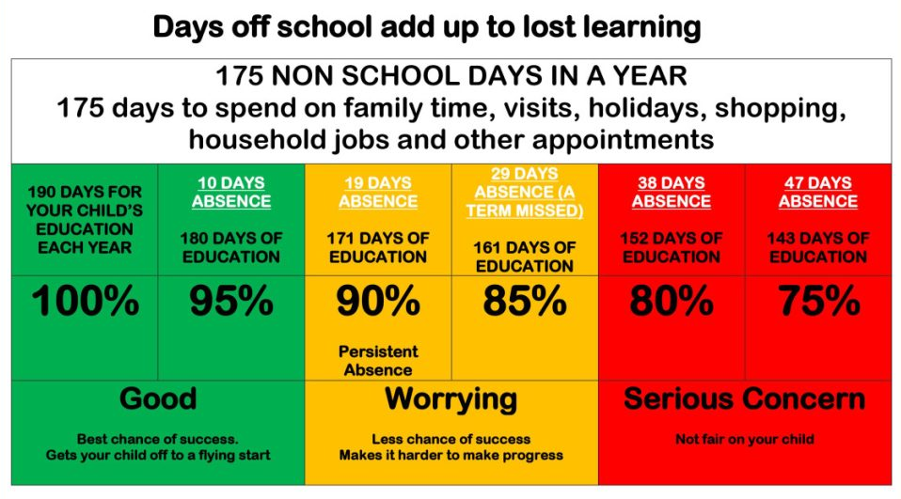

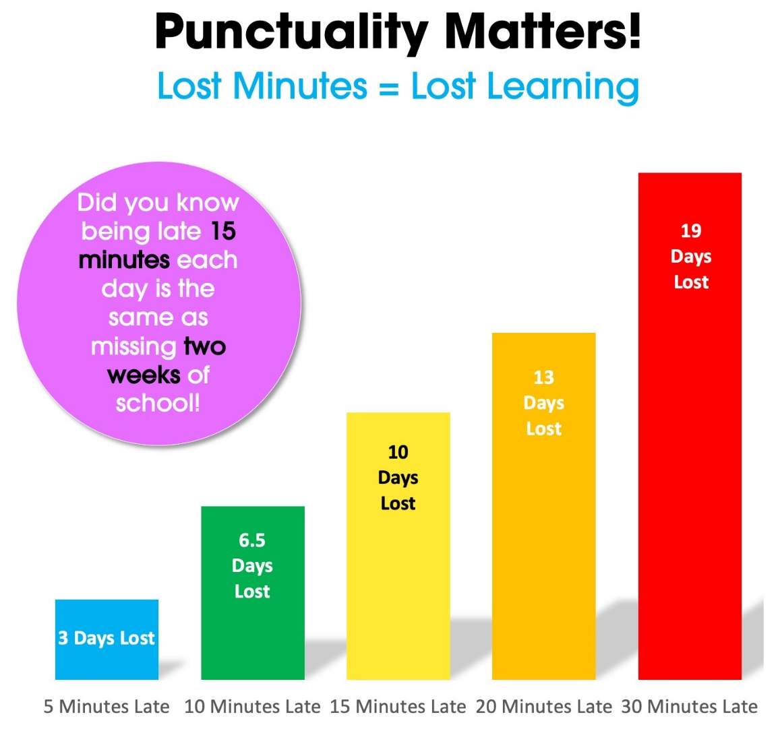

APPENDIX 1: ATTENDANCE CODES

Register Code | Description
/ | Present AM
\ | Present PM
L | Late (before registers closed) marked as present
K | Attending education provision arranged by the local authority
C | Authorised absence as pupil is absent due to other authorised circumstances
C1 | Leave of absence for the purpose of participating in a regulated performance or undertaking regulated employment abroad.
C2 | Leave of absence for a compulsory school age pupil subject to a part-time timetable
E | Authorised absence as pupil is excluded, with no alternative provision made
I | Illness (NOT appointments)
M | Authorised absence due to medical/dental appointments
R | Authorised absence due to religious observance
S | Authorised absence due to study leave
T | Authorised absence due to traveller absence
J1 | Leave of absence for the purpose of attending an interview for employment or for admission to another educational institution
B | Approved education activity as pupil being educated off site (NOT dual registration)
P | Approved educational activity as pupil is attending an approved sporting activity
V | Approved education activity as pupil is away on an educational visit or trip
W | Approved educational activity as pupil is attending work experience
K | Attending education provision arranged by the local authority
G | Unauthorised absence as pupil is on a family holiday, NOT agreed, or is taking days in excess of an agreed family holiday
N | Unauthorised absence as pupil missed sessions for a reason that has not yet been provided
O | Unauthorised absence as pupil missed sessions for an unauthorised absence not covered by any other code/description
U | Unauthorised absence as pupil arrived after registers closed
D | Dual registered (at another establishment - NOT counted in possible attendance
X | Not required to be in school - for non-compulsory school age children
Y | Unable to attend due to exceptional circumstances - not counted in possible attendances
Z | Pupil not yet on roll - not counted in possible attendances
# | Planned whole or partial school closure - NOT counted in possible attendances
Q | Unable to attend the school because of a lack of access arrangements
Y1 | Unable to attend due to transport normally provided not being available
Y2 | Unable to attend due to widespread disruption to travel
Y3 | Unable to attend due to part of the school premises being closed
Y4 | Unable to attend due to the whole school site being unexpectedly closed
Y5 | Unable to attend as pupil is in criminal justice detention
Y6 | Unable to attend in accordance with public health guidance or law
Y7 | Unable to attend because of any other unavoidable cause

