Maths: Multiply a Fraction by an Integer?

What Have We Learnt? Multiplying a fraction by a whole number (integer) means adding the fraction lots of times.

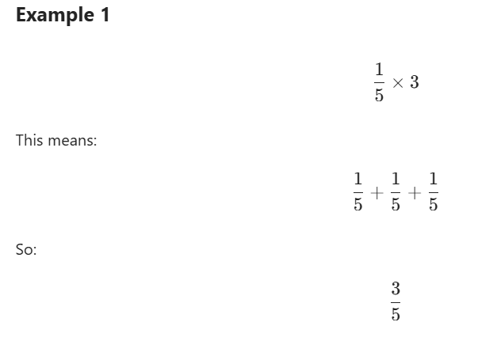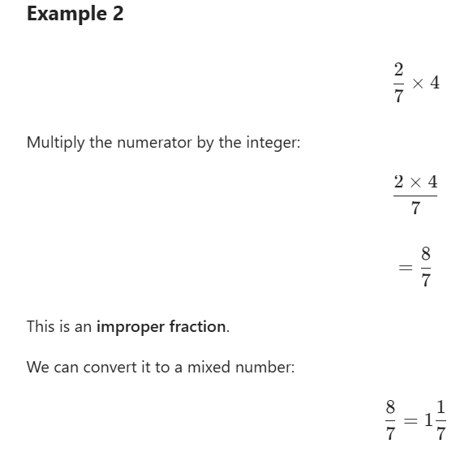

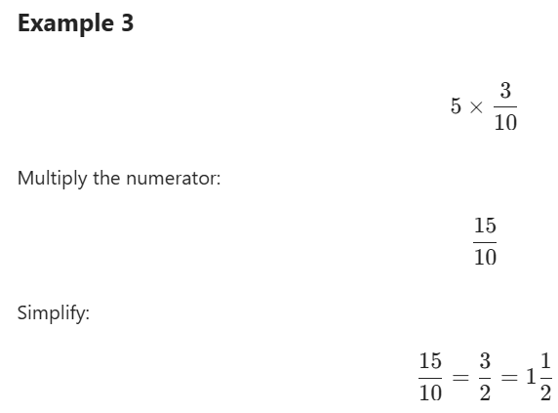

Top Tip
When multiplying a fraction by an integer:
- Multiply the numerator by the integer. 2. Keep the denominator the same.
- Simplify if possible. 4. Convert improper fractions into mixed numbers if needed.
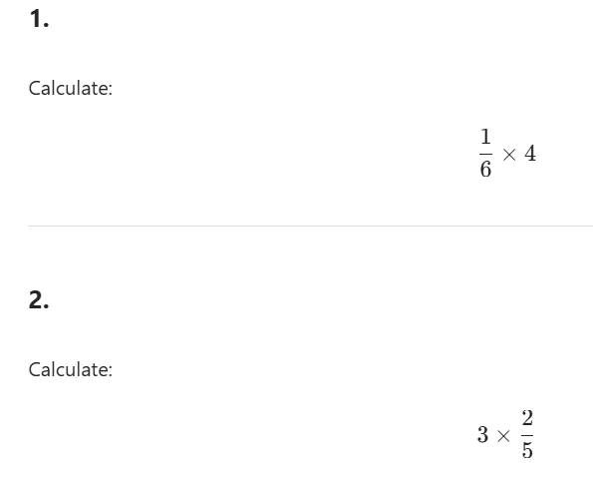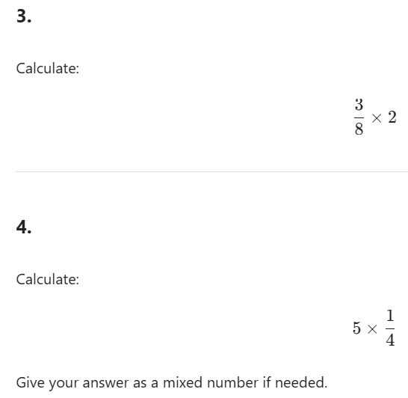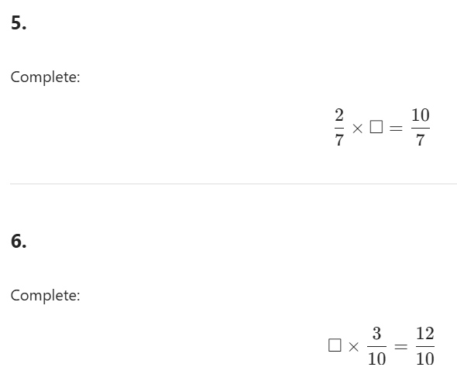
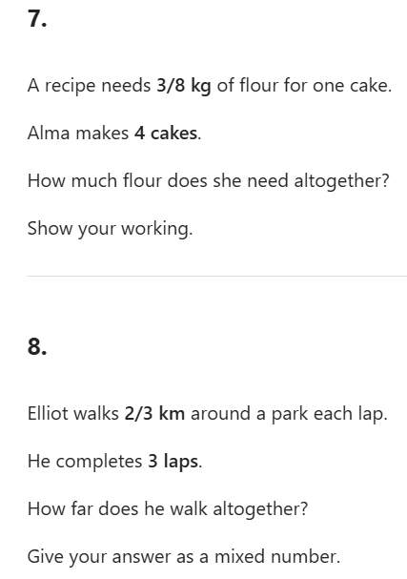

Spellings:
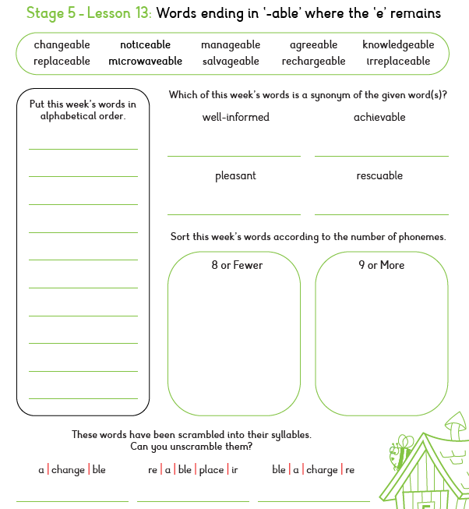

SPAG: Semi-Colons to Link Clauses
Using Semi-Colons - A semi-colon (;) joins two closely related main clauses. A semi-colon primarily replaces coordinating conjunctions (and, but, or, nor, for, yet, so) when they are omitted between two independent clauses.
Example: Both parts make sense on their own.
1) Elliot wanted to leave immediately; the prisoner was becoming more dangerous.
2) Virgo looked around nervously; something felt wrong.

1. Tick the sentence where the semi-colon correctly replaces a conjunction.
☐ Elliot pushed open the door; and he stepped carefully inside.
☐ Elliot pushed open the door; he stepped carefully inside.

2. Rewrite this sentence, replacing the conjunction with a semi-colon.
Virgo wanted to help Elliot but she could not reveal everything.

3. Circle the coordinating conjunction that could replace the semi-colon.
Prisoner Forty-Two smiled; Elliot stepped backwards. a) and b) or c) yet

4. Insert a semi-colon in the correct place: The prison door creaked open the corridor beyond was completely silent.

5. Which sentence uses a semi-colon correctly?
☐ The prisoner escaped; because no one was watching. ☐ The prisoner escaped; no one was watching.

6. Rewrite the sentence by removing the conjunction and replacing it with a semi-colon.
Elliot was frightened so he stayed close to Virgo.

7. Choose the best conjunction that could replace the semi-colon.
Virgo recognised the prisoner; Elliot had never seen him before. a) and b) but c) so

8. Write your own sentence about Prisoner 42 using a semi-colon to replace a coordinating conjunction. Example: The prisoner appeared harmless ; Virgo did not trust him.

