Maths: Identify Common Factors

What are factors?
A factor is a number that divides exactly into another number.
For example:
Factors of 12: 1, 2, 3, 4, 6, 12 Factors of 18: 1, 2, 3, 6, 9, 18

✅ What are common factors?
A common factor is a factor that appears in both lists.
For 12 and 18:
Factors of 12 | Factors of 18
1 | 1
2 | 2
3 | 3
4
6 | 6
12

Common factors = 1, 2, 3 and 6

✏️ Worked Example
Find the common factors of 16 and 24.
Factors of 16: 1, 2, 4, 8, 16 Factors of 24: 1, 2, 3, 4, 6, 8, 12, 24
Common factors: 1, 2, 4, 8

Fluency Questions

List all the factors of 20.

List all the factors of 30.

Circle the common factors of 20 and 30.

Find all the factors of 15.

Find all the factors of 25.

What common factors do 15 and 25 have?

Find the common factors of 18 and 24.

Reasoning and Problem Solving
Amir says: "The common factors of 16 and 20 are 1, 2 and 4." Is Amir correct? Explain how you know.

A number has the factors: 1, 2, 4, 7, 14 and 28. It shares the common factors 1, 2, 4 and 14 with another number. What could the other number be? Explain your reasoning.

Spellings:
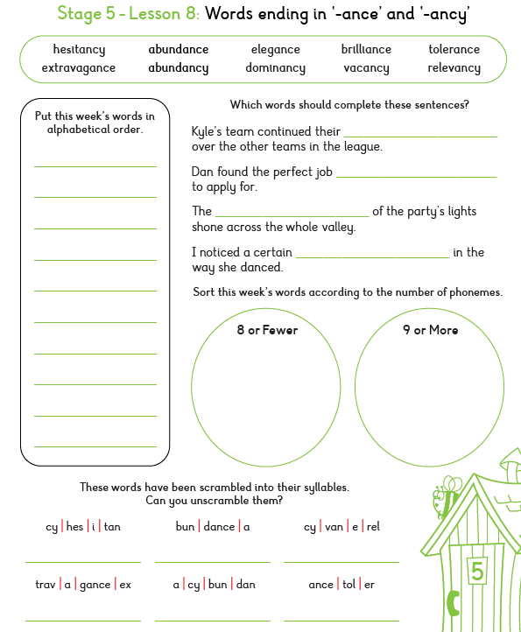
SPAG: Parenthesis (Brackets, Commas and Dashes)

What is Parenthesis?
Parenthesis is extra information added to a sentence. It gives the reader more detail but is not essential for the sentence to make sense. The extra information can be marked using:

Brackets: Elliot (feeling nervous) followed Virgo into the prison.

Commas: Elliot, feeling nervous, followed Virgo into the prison.

Dashes: Elliot - feeling nervous - followed Virgo into the prison.

If we remove the extra information, the sentence still makes sense: Elliot followed Virgo into the prison.

Questions

1. Tick the sentence that uses parenthesis correctly.
□ The prisoner trapped for centuries called out.
□ The prisoner, trapped for centuries, called out.
□ The prisoner trapped, for centuries called out.

2. Add brackets around the parenthesis.
The prison had been forgotten by everyone for hundreds of years.

3. Underline the parenthesis.
Virgo, ignoring Elliot's questions, walked deeper into the prison.

4. Rewrite using commas for parenthesis.
The prisoner (desperate for freedom) shouted for help.

5. Rewrite using dashes for parenthesis.
Zeus, ruler of Olympus, had vanished. ___________________________________________________

6. Which sentence uses parenthesis correctly? Circle it
A. Elliot, nervously entered the prison. B. Elliot, feeling nervous, entered the prison.
C. Elliot feeling, nervous entered the prison. D. Elliot feeling nervous entered the prison.

