Maths: Prime Number

What is a Prime Number?
A prime number has exactly two factors:
- 1
- Itself

✅ Examples
7 is prime because its factors are: 1 and 7
13 is prime because its factors are: 1 and 13

❌ Not Prime
12 is not prime because its factors are: 1, 2, 3, 4, 6, 12
It has more than two factors, so it is called a composite number.

⭐ Top Tip
To decide if a number is prime:
- List its factors.
- Count them.
- If there are exactly 2 factors, it is prime.

Fluency Questions

Circle the prime numbers: 2 4 5 6 7 8

List the factors of 11. Is 11 prime?

List the factors of 15. Is 15 prime?

Complete the table:
Number | Prime or Not Prime?
13
20
29
30
- Find all the prime numbers between 10 and 20.
- Find all the prime numbers between 20 and 30.
- True or False? 25 is a prime number. Explain your answer.

Reasoning and Problem Solving
A number has exactly two factors. Amir says: "The number must be prime." Is Amir correct? Explain why.

Spellings:
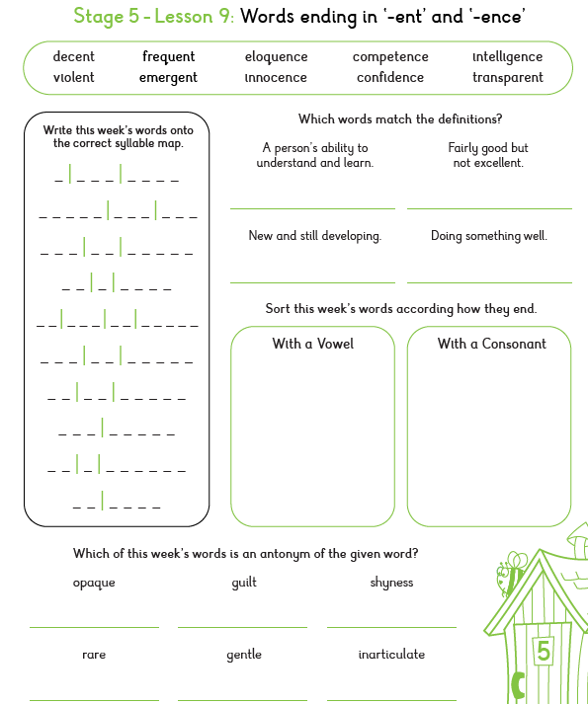

SPAG: Commas to avoid ambiguity

What Does "Ambiguity" Mean? Ambiguity means that a sentence could have more than one meaning. Sometimes a comma helps the reader understand exactly what the writer means.

Example 1
Without comma: The children watched the ducks by the pond. This means the ducks were by the pond.
With comma: The children watched the ducks, by the pond. This means the children were by the pond while watching the ducks.
The comma changes who the information refers to.

Example 2
Without comma: Elliot spoke to the prisoner in the dark cell. The prisoner is in the dark cell.
With comma: Elliot spoke to the prisoner, in the dark cell. Elliot is in the dark cell.

Example 3
Without comma: Virgo found clues beside the prison gate. The clues were beside the prison gate.
With comma: Virgo found clues, beside the prison gate. Virgo was beside the prison gate when she found the clues.

1. Tick the sentence where the prisoner is in the cell.
□ The gods spoke to the prisoner in the cell. □ The gods spoke to the prisoner, in the cell.

2. Read the two sentences.
A: Elliot heard a voice behind the prison bars. B: Elliot heard a voice, behind the prison bars.
How does the comma change the meaning?

3. Draw a line to match each sentence with its correct meaning.
a) Virgo followed Elliot through the prison tunnel. b) Virgo followed Elliot, through the prison tunnel.
Meanings:
- Virgo is travelling through the prison tunnel.
- Elliot is travelling through the prison tunnel.

4. Read the sentence: The gods searched for Zeus inside the temple. Who is inside the temple? Circle the answer.
A) Zeus B) The gods C) Both Zeus and the gods D) Nobody knows

5. Explain How the Comma Changes Meaning
A: The prisoner shouted to the visitors from his cell. B: The prisoner shouted to the visitors, from his cell.
Explain the difference between the two sentences.

6. Add a comma to change the meaning of the sentence. The children watched Virgo beside the old prison gate.
Now explain how the meaning has changed.

