Maths: Recognise and use square and cube numbers

What are Square Numbers? A square number is the result of multiplying a number by itself.

Examples
- 1 × 1 = 1
- 2 × 2 = 4
- 3 × 3 = 9
- 4 × 4 = 16
- 5 × 5 = 25
We can write these as:
- 1² = 1
- 2² = 4
- 3² = 9
- 4² = 16
- 5² = 25

First 12 Square Numbers
1, 4, 9, 16, 25, 36, 49, 64, 81, 100, 121, 144

What are Cube Numbers? A cube number is the result of multiplying a number by itself twice.

Examples
- 1 × 1 × 1 = 1 2 × 2 × 2 = 8 3 × 3 × 3 = 27 4 × 4 × 4 = 64
We can write these as:
- 1³ = 1 2³ = 8 3³ = 27 4³ = 64

First 10 Cube Numbers
1, 8, 27, 64, 125, 216, 343, 512, 729, 1000

Fluency
- Complete:
- 2² = _____ 6² = _____ 10² = _____
- Complete:
- 2³ = _____ 3³ = _____ 5³ = _____
- Circle all the square numbers: 9 12 16 20 25 30
- Circle all the cube numbers: 8 12 27 36 64 81
- What is the next square number? 1, 4, 9, 16, 25, _____
- What is the next cube number? 1, 8, 27, 64, _____
- Which square number is missing? 36, 49, _____, 81

Reasoning and Problem Solving
Rosie says: "Every cube number is also a square number." Is Rosie correct?
Use examples to explain your answer.

Spellings:
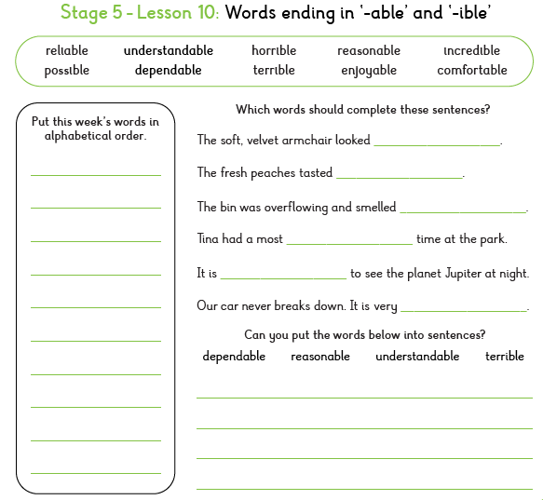

SPAG: Passive Voice

What is the Passive Voice?
In an active sentence, the subject performs the action.
Active: Elliot opened the prison cell.
In a passive sentence, the action happens to the subject.
Passive: The prison cell was opened by Elliot.
Look for: was, were, is, are, been, being; past-tense verb (opened, discovered, hidden)

Example
Active: Virgo released Prisoner Forty-Two.
Passive: Prisoner Forty-Two was released by Virgo.

1. Tick the sentence written in the passive voice.
☐ Elliot discovered the prisoner. ☐ The prisoner was discovered by Elliot.

2. Underline the passive verb in this sentence: The chains were removed by Virgo.

3. Rewrite the sentence in the passive voice: Elliot opened the heavy door.

4. Complete the sentence using a passive verb: The key __________ by the prisoner.

5. Which sentence sounds more formal?
A. Elliot found the prisoner. B. The prisoner was found by Elliot.

6. Circle the passive sentence.
a) Virgo unlocked the cage. b) The cage was unlocked by Virgo.

7.Rewrite in the passive voice: Zeus protected the prisoner.

8. Why might an author choose to use the passive voice here?
The prison cell was secretly guarded.

