Maths: Compare and Order Fractions (Same Numerator or One Common Denominator)

What Have We Learnt? When fractions have the same denominator, the fraction with the largest numerator is greater.

Example 1
Compare: 3/8 and 5/8
Both fractions have 8 as the denominator.
Since 5 > 3,
5/8 > 3/8

When fractions have the same numerator, the fraction with the smallest denominator is greater because the whole has been split into fewer parts.

Example 2
Compare:
3/4 and 3/8
The numerator is the same (3).
Fourths are larger than eighths, so:
3/4 > 3/8

Ordering Fractions
Order from smallest to largest:
2/10, 7/10, 4/10, 1/10
Look at the numerators:
1/10 < 2/10 < 4/10 < 7/10

1. Circle the larger fraction. 3/7 or 5/7

2. Circle the larger fraction.
2/5 or 2/9

3. Complete using <, > or =
4/8 ☐ 6/8

4. Complete using <, > or =
5/6 ☐ 5/12

5. Order these fractions from smallest to largest.
7/9, 2/9, 5/9, 1/9

6. Order these fractions from largest to smallest.
3/5, 1/5, 4/5, 2/5

7. Which fraction is the odd one out?
4/10, 7/10, 4/5, 8/10
Explain your answer.

8. Rosie says: "7/12 is greater than 7/6 because 12 is bigger than 6." Is Rosie correct?
Explain why.
Spellings:
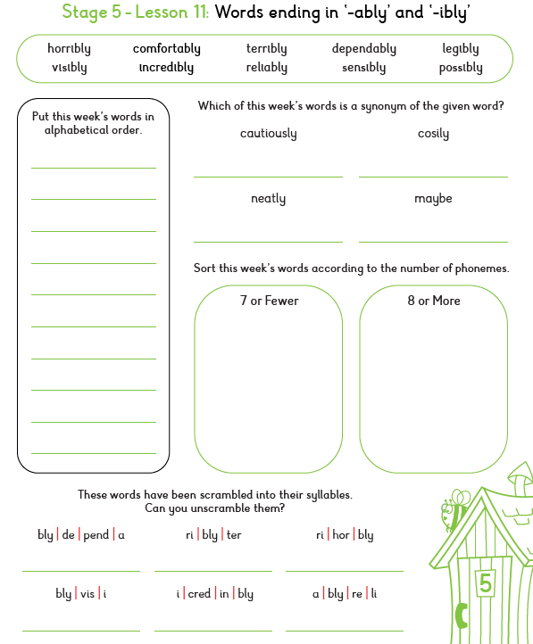

SPAG: Hyphens to Avoid Ambiguity

What is Ambiguity? An ambiguous sentence can be understood in more than one way. Hyphens help make meaning clear.

Examples
Without a hyphen: a man eating shark
With a hyphen: a man-eating shark
A hyphen changes the phrase from a human sitting down to eat a seafood meal into a predatory animal
Without a hyphen: small animal hospital
With a hyphen: small-animal hospital
Small animal hospital: This can mean an animal hospital that happens to be physically small in size.
Small-animal hospital: The hyphen links "small" and "animal" together as a single descriptive unit (a phrasal adjective) that modifies "hospital," meaning a hospital that treats small animals

1. Tick the correctly punctuated sentence.
☐ Elliot met a fast moving prisoner. ☐ Elliot met a fast-moving prisoner.

2. Add a hyphen where needed: The long term prisoner sat quietly.

3. Write the missing hyphenated word: The __________ guard watched every movement. (sharp eyed)

4. Which sentence is clearer? A. A small animal cage. B. A small-animal cage.

5. Add a hyphen: The well known prisoner smiled.

6. Circle the sentence that needs a hyphen.
a) The cell door was locked. b) The brightly lit corridor was empty.

7. Insert a hyphenated adjective before the noun.
Elliot followed a __________ pathway. (poorly lit)

8. Explain why a hyphen is needed in this phrase: a stone faced guard

