Maths: Add and Subtract Fractions with the Same Denominator?

What Have We Learnt?
When fractions have the same denominator, we add or subtract the numerators and keep the denominator the same.

Adding Fractions - Example 1: 2/8 + 3/8= 5/8
Add the numerators:
2 + 3 = 5
Keep the denominator:
= 5/8

Subtracting Fractions -

Example 2: 7/10 – 4/10
Subtract the numerators:
7 - 4 = 3
Keep the denominator:
= 3/10

Simplifying Answers

Example 3: 2/6 + 2/6 = 4/6 ​
4/6 can be simplified to 2/3

1. Calculate: 2/7 + 3/7

2. Calculate: 5/9 + 2/9

3. Calculate: 8/10 – 3/10

4. Calculate: 7/12 – 5/12

5. Complete: 4/11+ □/11 = 9/11

6. Complete: □/8 – 2/8 = 4/8

7. Amir eats 3/10 of a pizza at lunch and 4/10 at dinner. What fraction of the pizza has he eaten altogether?

8. A strip of ribbon is 11/12 m long. 5/12 m is cut off. How much ribbon remains?

Spellings:
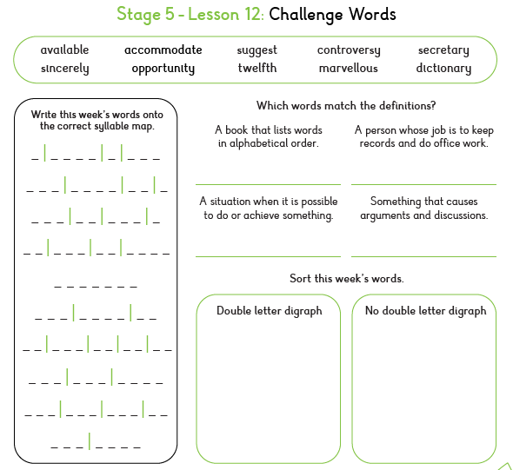

SPAG: Formal and Informal Language
Formal language is used in:
- Reports explanations official writing
Informal language is used in:
- Conversations texts speech

Examples
Informal: The prisoner just disappeared.
Formal: The prisoner mysteriously vanished.
Informal: The guard was really angry.
Formal: The guard appeared extremely frustrated.

1. Tick the most formal sentence.
☐ The prisoner legged it. ☐ The prisoner escaped.

2. Replace the informal word. The guard got really mad.
Formal version: _________________________________

3. Circle the formal word. Amazing excellent awesome

4. Which sentence would be most suitable for a report?
A. Elliot was pretty shocked. B. Elliot appeared extremely surprised.

5. Rewrite using more formal language:
The prisoner looked weird. _______________________________

6. Tick the informal phrase.
☐ extremely disappointed ☐ fed up

7. Choose the most formal word. The prisoner ___________________ from the cell.
A. shot off B. disappeared C. zoomed away

8. Rewrite the sentence in a formal style: Elliot was a bit worried about what he saw.

